Assignment

Name : B. Harishwar Reddy
Reg.No. : 192311338
Course Code : CSA1023
Course Name : Software Engineering

Title:
Academic & Resource Management System (ARMS) for SIMATS University

Project Overview:
The Academic & Resource Management System (ARMS) aims to digitalize and streamline the academic and administrative processes at SIMATS University. This system will integrate student information, faculty management, resource allocation, and academic tracking under one unified platform.
Project Objectives:
- Develop a centralized system to manage student data.
- Automate administrative tasks such as attendance, grading, and course management.
- Enhance communication between students, faculty, and administration.
- Provide real-time analytics and reporting and gradings.
- Ensure data security and compliance with academic regulations.
Scope of Work:
- Requirement Analysis:
  - Gather user requirements from faculty, students, and administrators.
  - Identify key features and functionalities.
- System Design:
  - Develop system architecture.
  - Plan database structure.

- Development Phase:
  - Implement core modules: Student Information System, Faculty Management, Course Management, Attendance Tracking, Examination & Grading, and Resource Management.
  - Develop APIs for system integration.
  - Ensure mobile and web compatibility.
- User Profile Page Development:
  - Design and implement a dedicated User Profile Page for students, faculty, and administrators.
  - Include personal details, academic history, and resource access.
  - Provide options for profile customization and security settings.
  - Enable document uploads and digital verification of credentials.
- Testing & Quality Assurance:
  - Conduct unit testing and integration testing.
  - Gather feedback and make necessary improvements.
- Deployment & Training:
  - Deploy system on university servers.
  - Conduct training sessions for faculty and students.
  - Provide technical documentation.
- Post-Implementation Support:
  - Monitor system performance.
  - Address any technical issues.
  - Roll out updates and improvements.
JIRA Project Setup:
- Project Type: Software Development
- Board Type: Scrum/Kanban
- Issue Types: Epic, Story, Task, Bug

- Workflows:
  - To Do → In Progress → Done
- Sprints & Milestones:
  - Sprint 1: Requirement Gathering & Analysis
  - Sprint 2: System Design & UI/UX
  - Sprint 3: Development of Core Modules
  - Sprint 4: User Profile Page Development
  - Sprint 5: Testing & Bug Fixing
  - Sprint 6: Deployment & Training
JIRA Task Breakdown:
- Epic 1: Requirement Analysis:
  - Create user requirement documents
  - Conduct stakeholder meetings
- Epic 2: System Design:
  - UI/UX wireframe creation
  - Database schema design
- Epic 3: Development:
  - Develop student module
  - Develop faculty management module
  - Develop User Profile Page
- Epic 4: Testing & QA:
  - Unit and integration testing
  - User acceptance testing
- Epic 5: Deployment & Training:
  - Deploy on servers

KANBAN BOARD:
- we are giving 15 tasks in TO-DO category based on the stakeholder’s interest,and we have to categorize them as done and in progress.
- Here we are aimed to create ARMS with 15 main tasks, and according to deadlines these tasks are categorized as done and in progress.
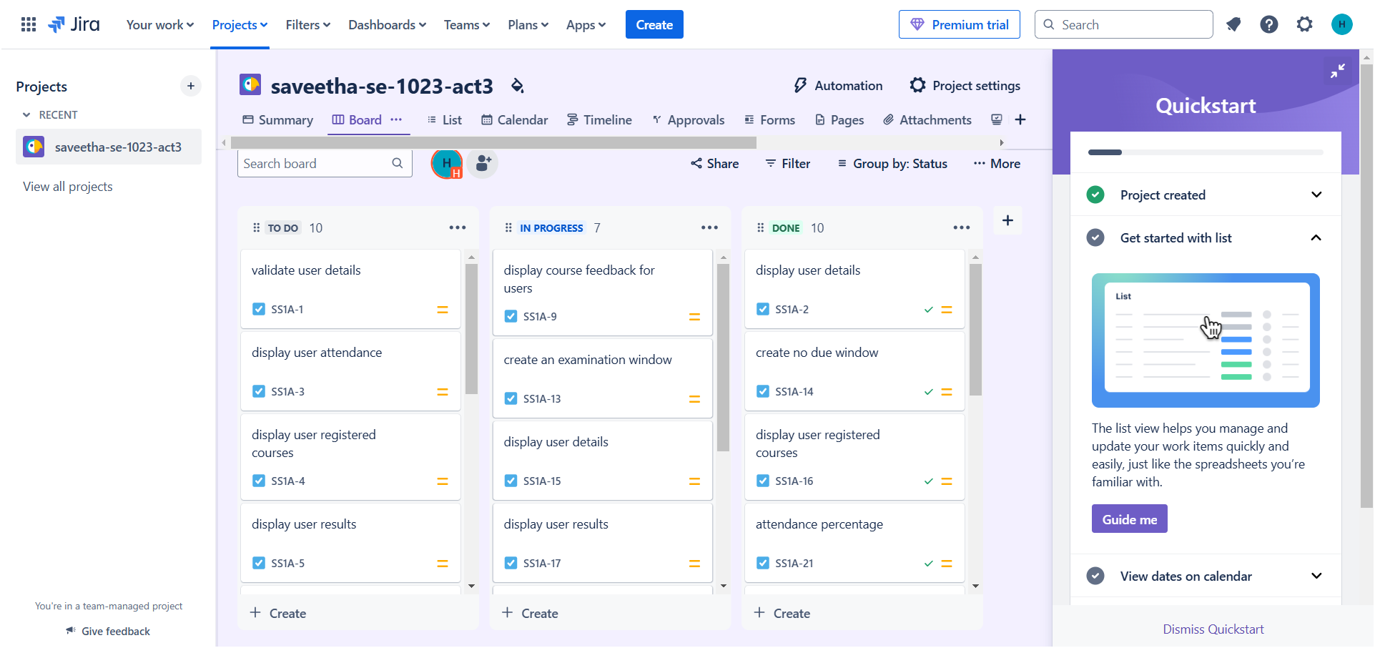
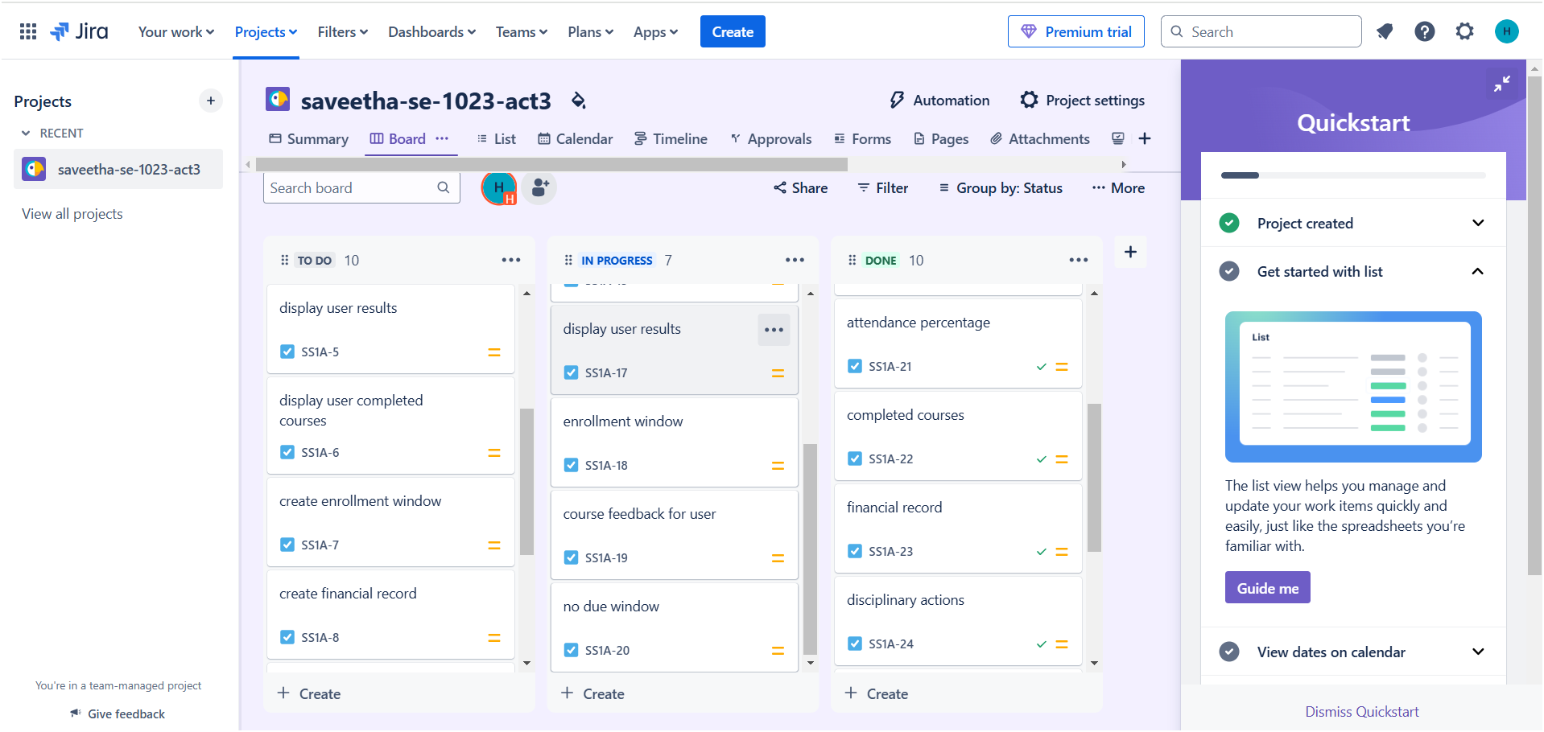
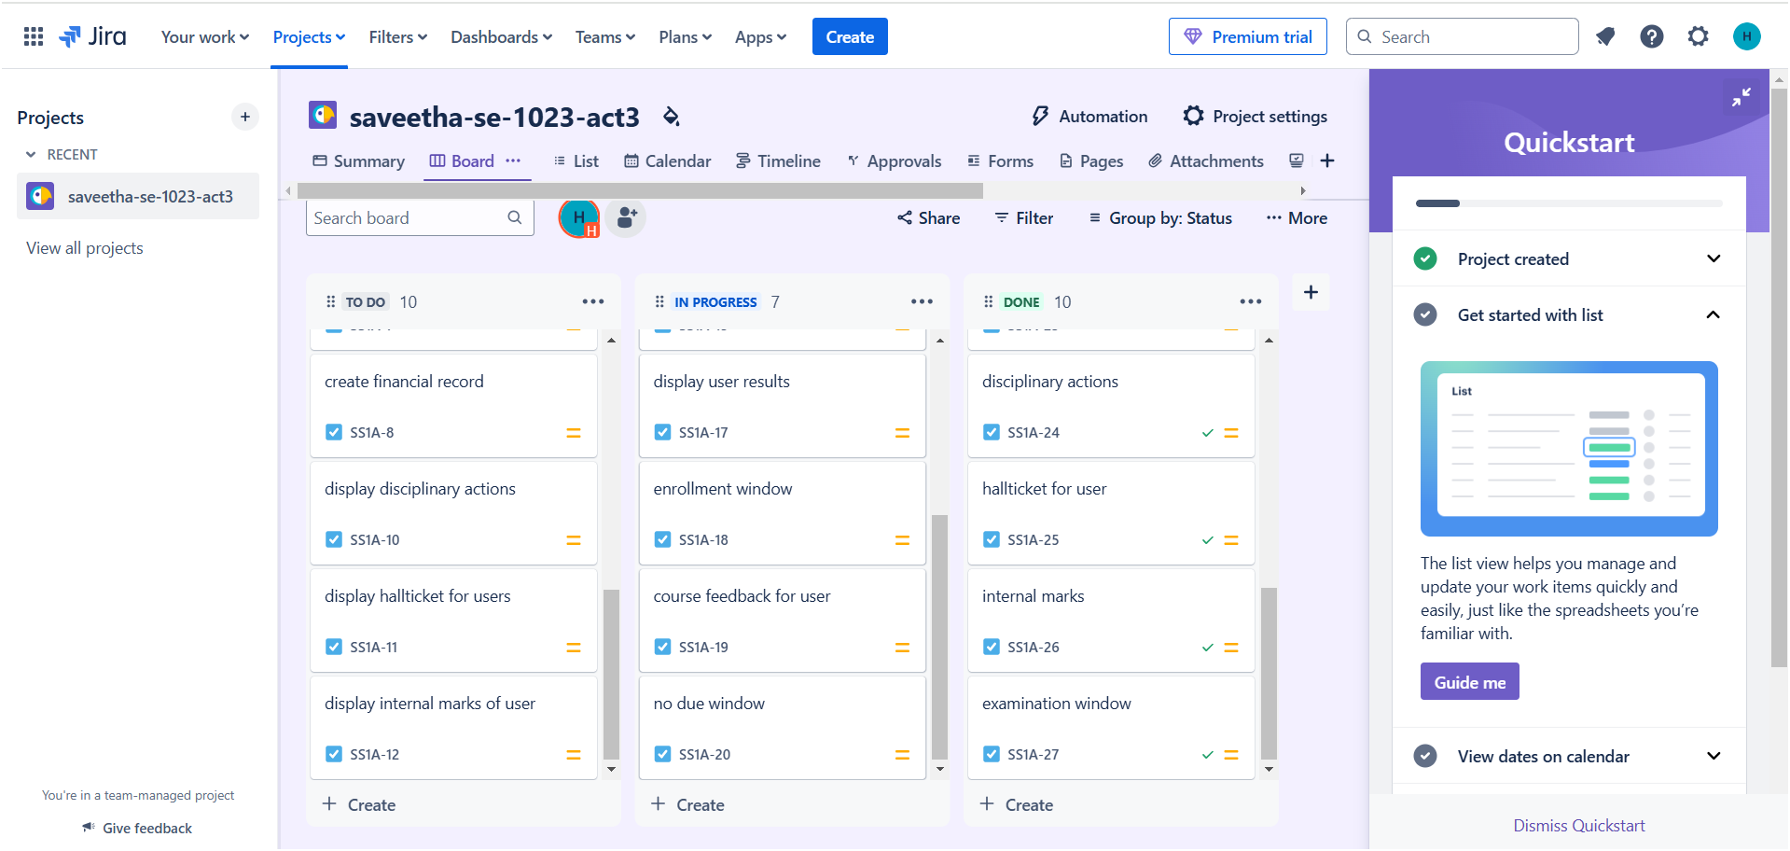
Timeline:
- We are giving the start date and end date for each task, by this we will give priority to the tasks according to deadlines.
- In the given picture below, I have given timelines to some of the tasks, so that the team will work based on it.

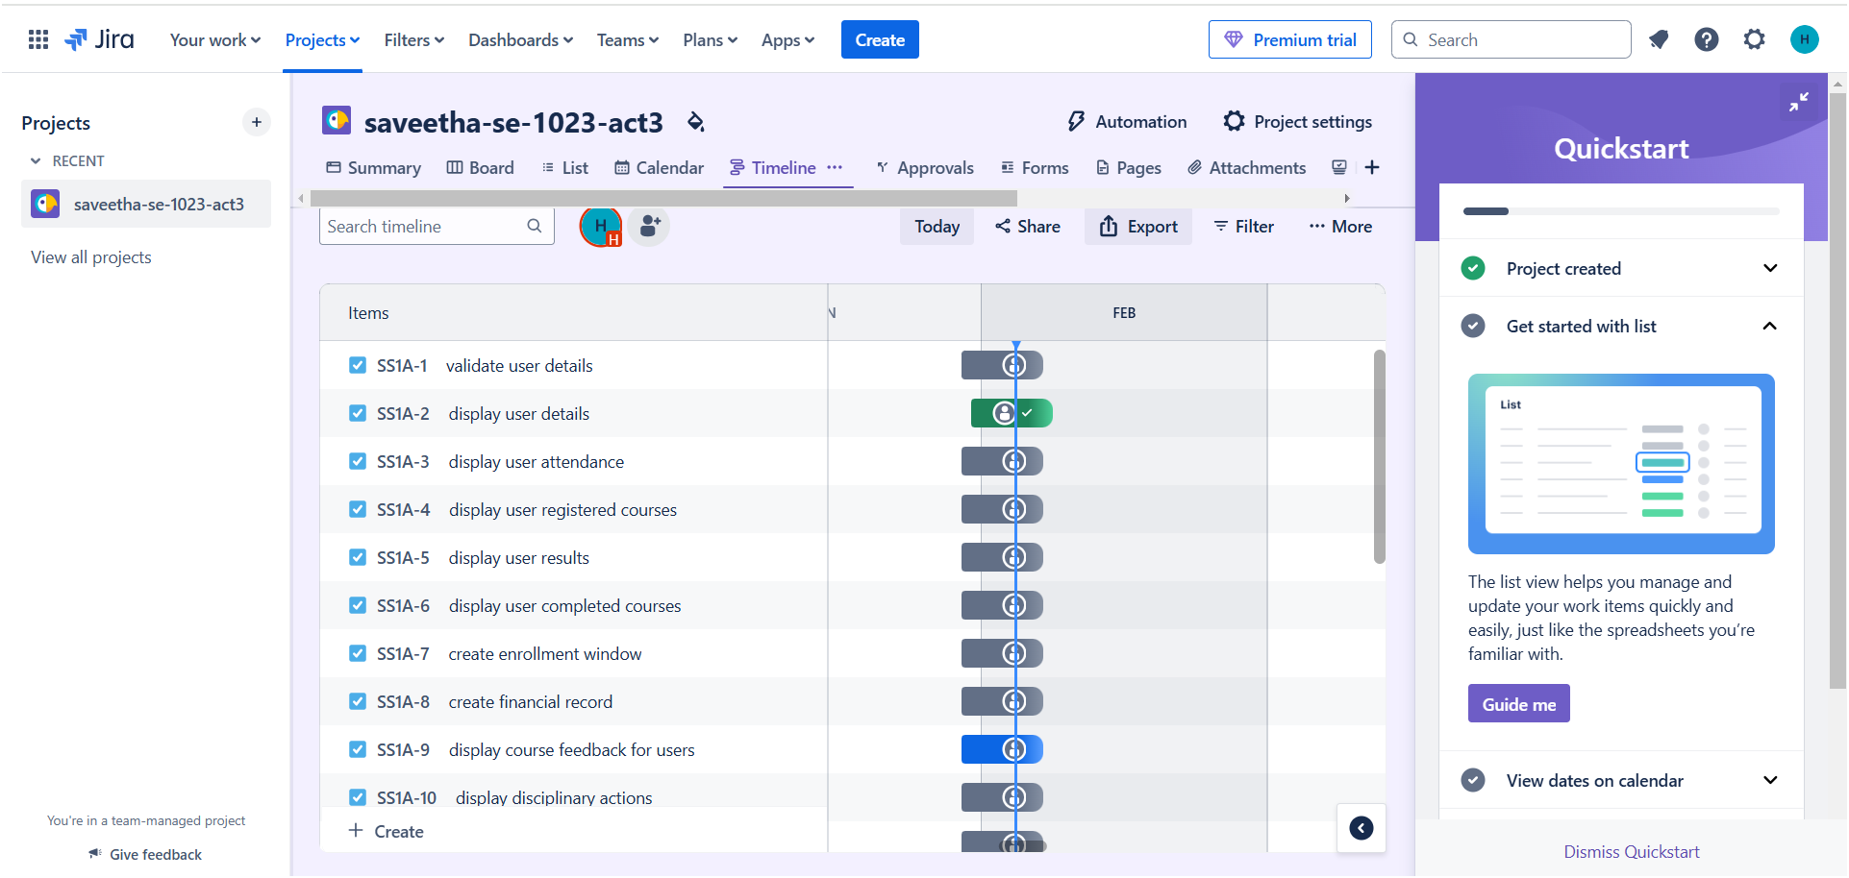
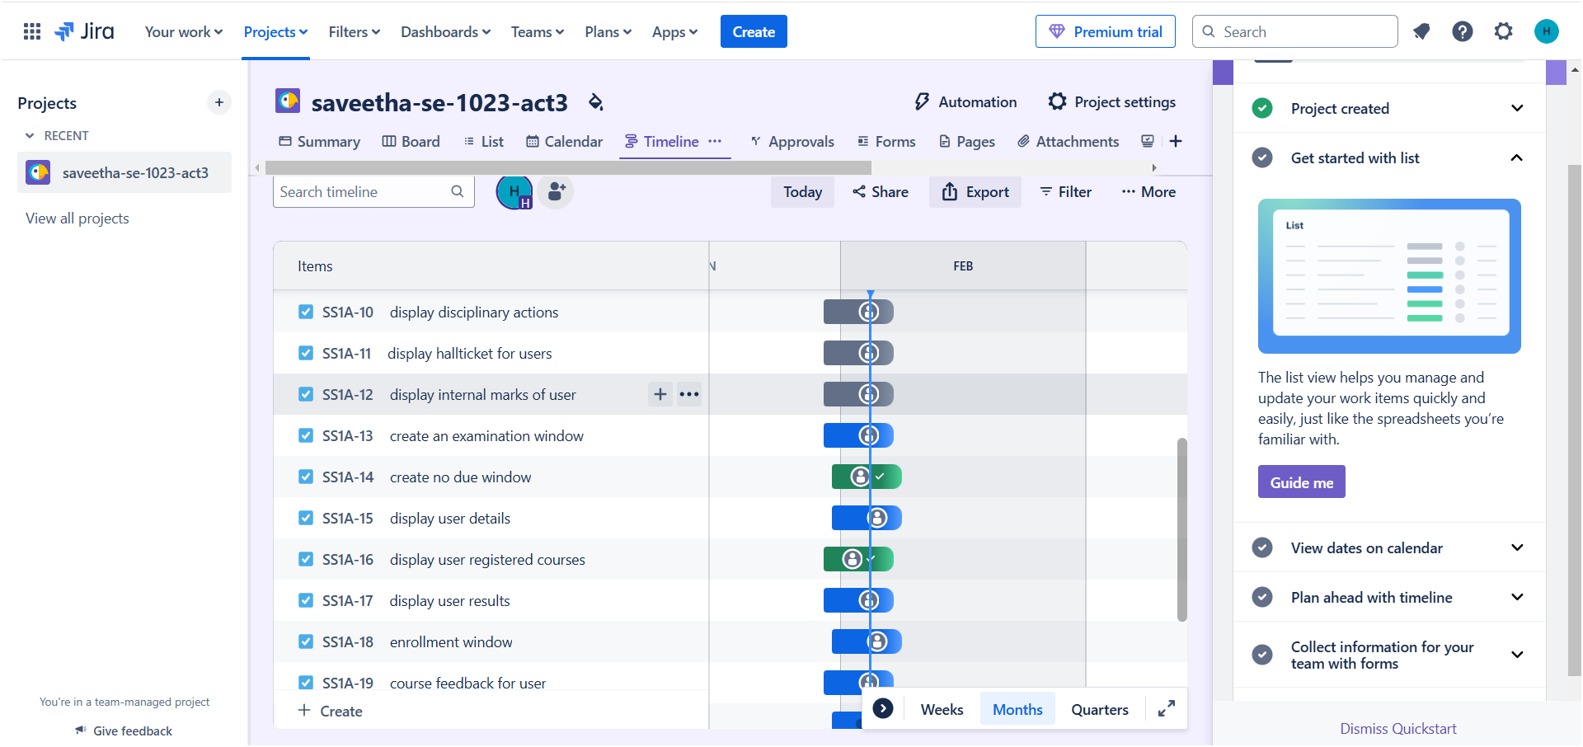

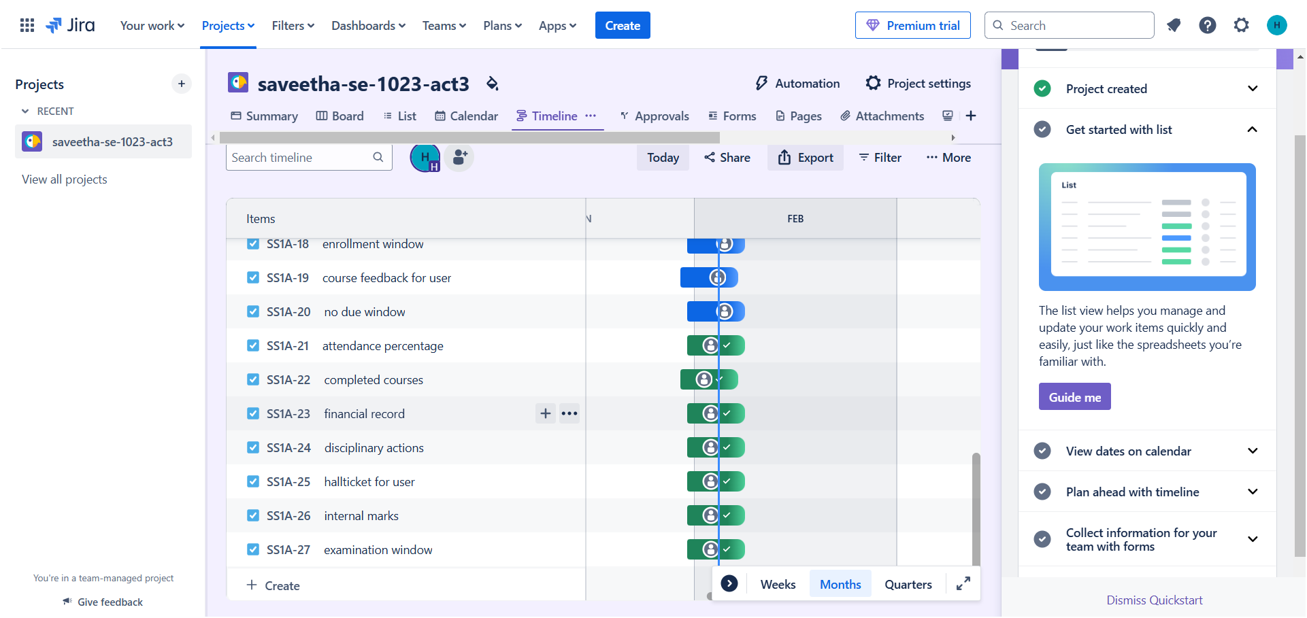

- From the above picture, the lesser the timeline has the highest priority, and more the timeline has the least priority.
List:
- with the use of list, we can have all information of tasks in a table, like tasks, timeline, assigned to, due dates, etc
- lists also helps to display the present status of the tasks like InProgress or done.
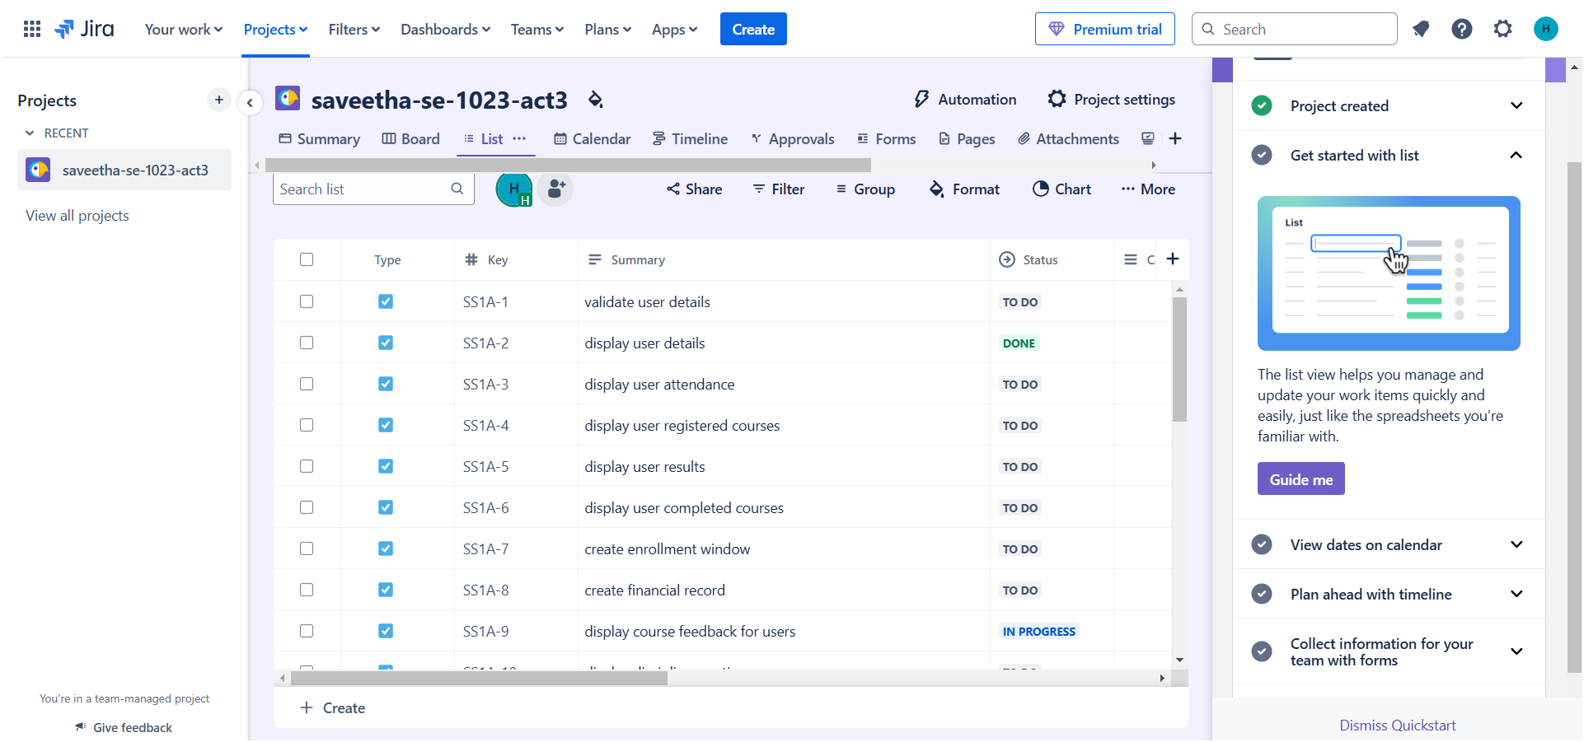
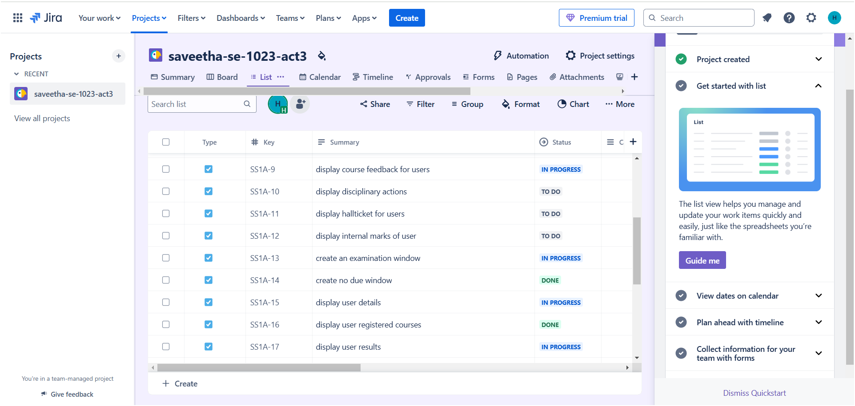
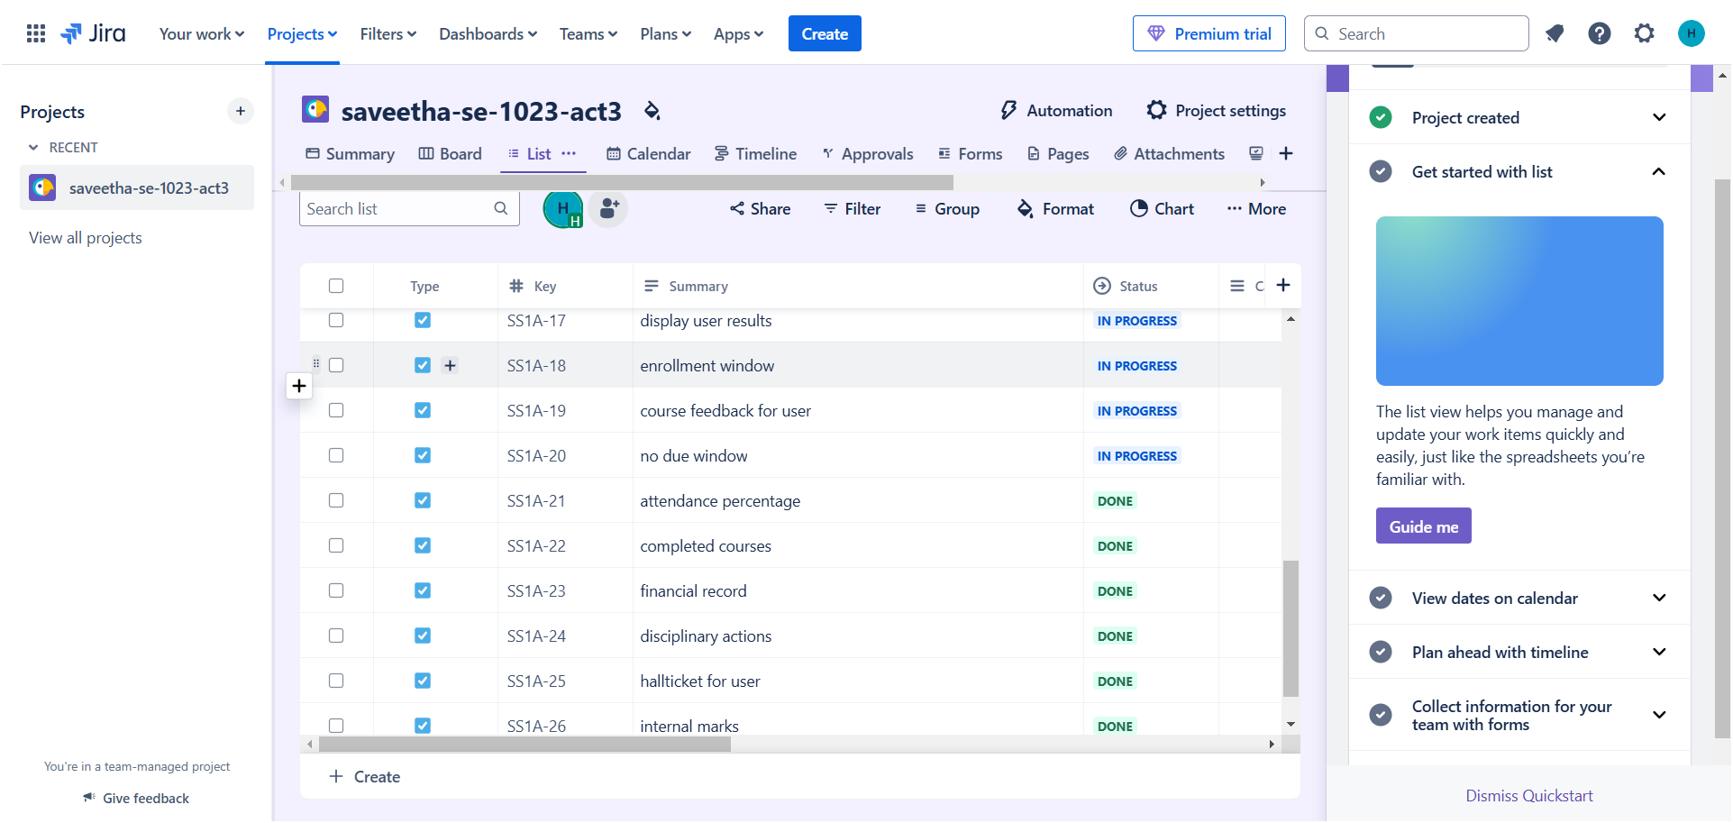

Summary:
- Through the help of summary, we can get an overview of status overview of tasks, activity of team members, due dates, priority breakdown, pie chart, graphs, team workload, and types of works.
- Summary is just like a conclusion of whole project details.

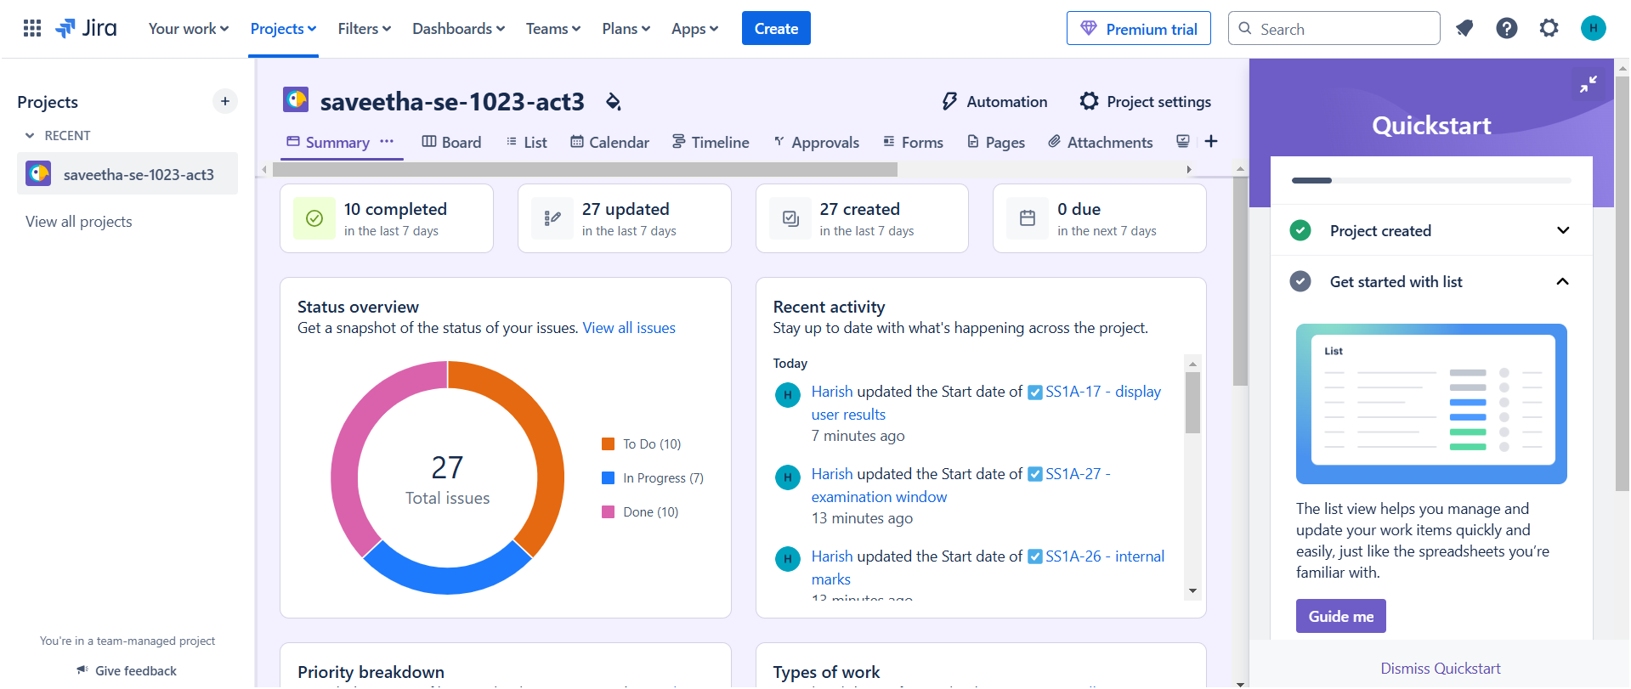

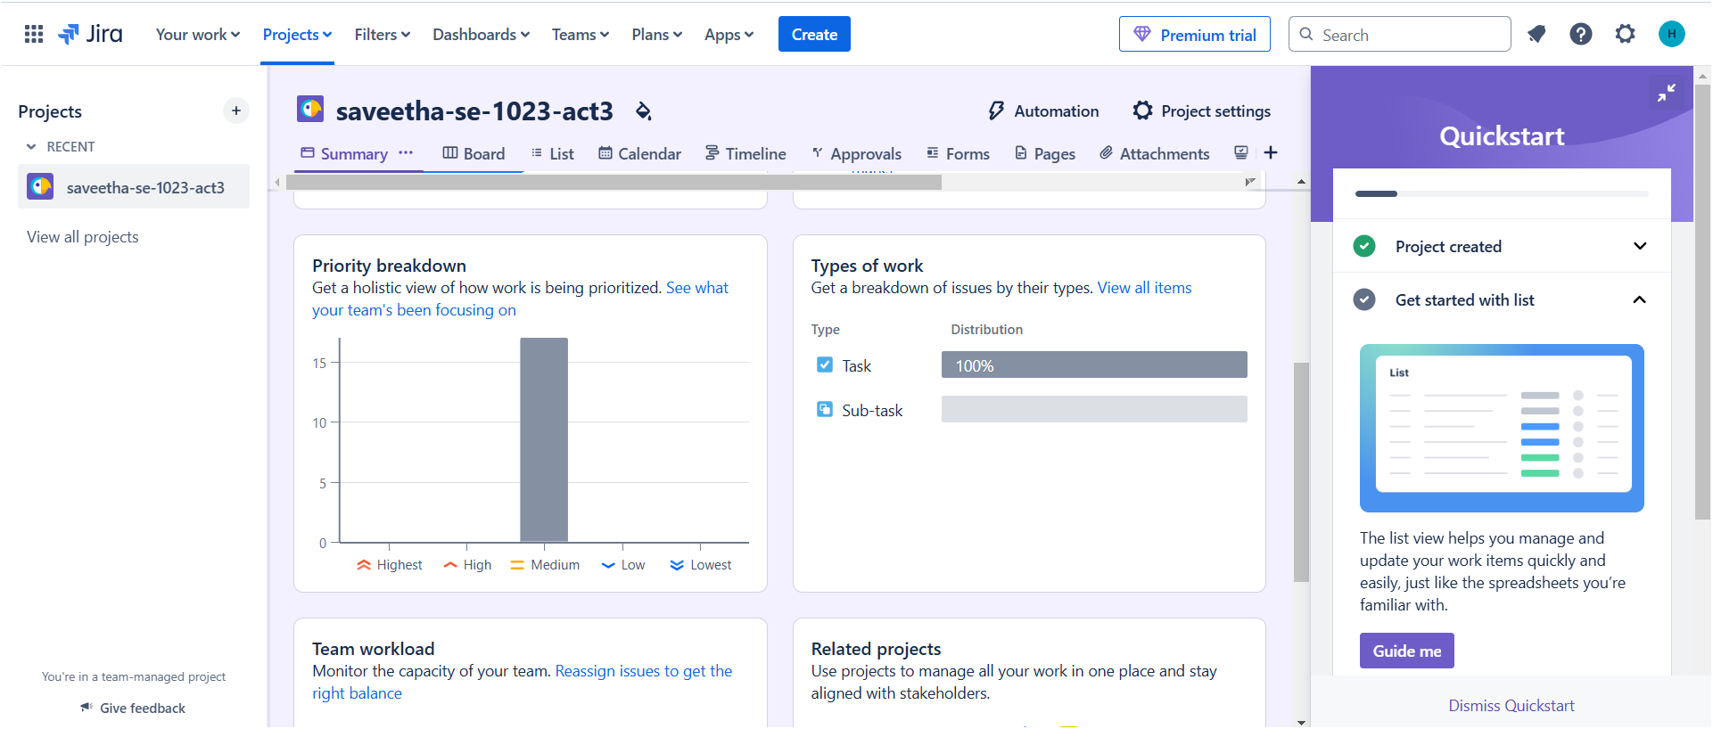

Project Deliverables:
- Functional ARMS software with core modules.
- Fully developed User Profile Page.
- System documentation and user manuals.
- Training sessions for faculty and students.
- Maintenance and support plan.
Timeline & Milestones:
- Phase 1: Requirement Analysis
- Phase 2: System Design
- Phase 3: Development
- Phase 4: User Profile Page Development
- Phase 5: Testing
- Phase 6: Deployment & Training
- Phase 7: Post-Implementation Support
Technology Stack:
- Frontend
- Backend
- Database
- Hosting
- Security
Risk Management:
- Data Security Risks: Implement strong encryption and access control.
- User Adoption Issues: Conduct thorough training sessions.
- Technical Challenges: Allocate buffer time for troubleshooting.
- Budget Constraints: Regular monitoring of financial resources.
Success Metrics:
- Reduced manual administrative workload.
- Improved communication within the university.
- Increased accuracy in academic data management.
- Positive feedback from faculty and students.
Conclusion:
The Academic & Resource Management System (ARMS) for SIMATS University streamlines the management of academic resources, enhancing efficiency in administrative tasks. It enables seamless integration of academic scheduling, resource allocation, and student management. Ultimately, ARMS fosters an organized and optimized educational environment, benefiting both faculty and students.

